|  |  |  |  |  |  |
| --- | --- | --- | --- | --- | --- |
| Date | 1-Dec-22 | | | Tester Name | Shahabuddin Syed |
| Environment | Penfax - Test | | | Login used |  |
| Operating System | Windows | Version: | Update: | | |
| Software Used | Edge | Version: | Update: | | |
| Select Software | Version: | Update: | | |
| Release version | 22.4.1 | | | | |
| Title | E21.01 | | | | |
| Test Type | Regression | | | | |
| Test Scenario | Track a member consultation | | | | |
|  |  | | | | |
| Expected Results |  | | | | |
| Pass/Fail | Pass | | | JIRA# | N/A |

Describe your steps with screenshots:

Search for an active member in the PEPP Plan

In Penfax do a member search

Click on their stakeholder ID Number

Select Stakeholder ID

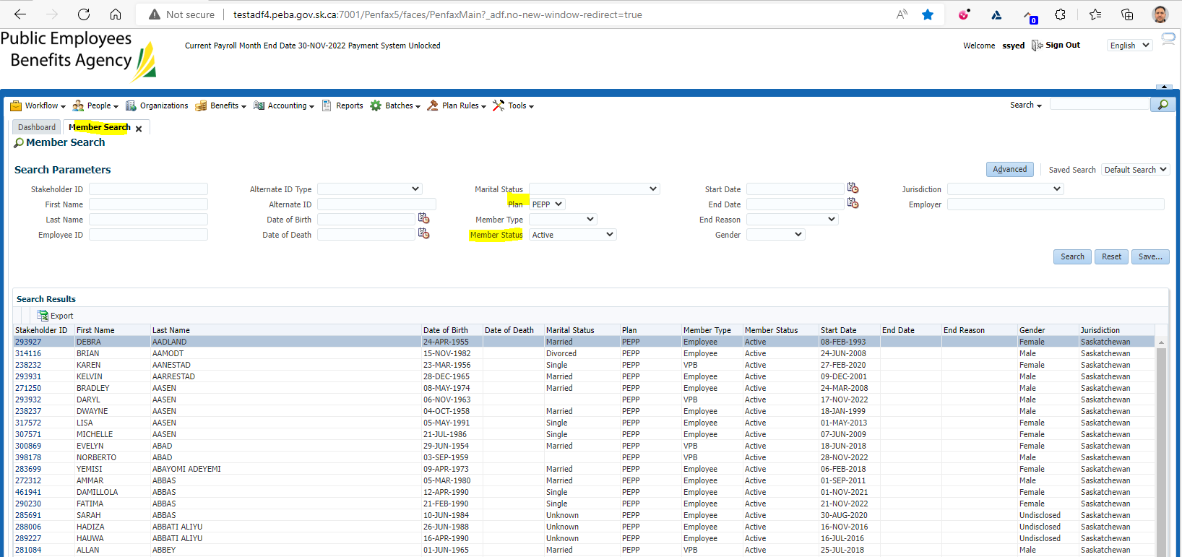

Click on Stakeholder ID

New window opens up with Member Profile

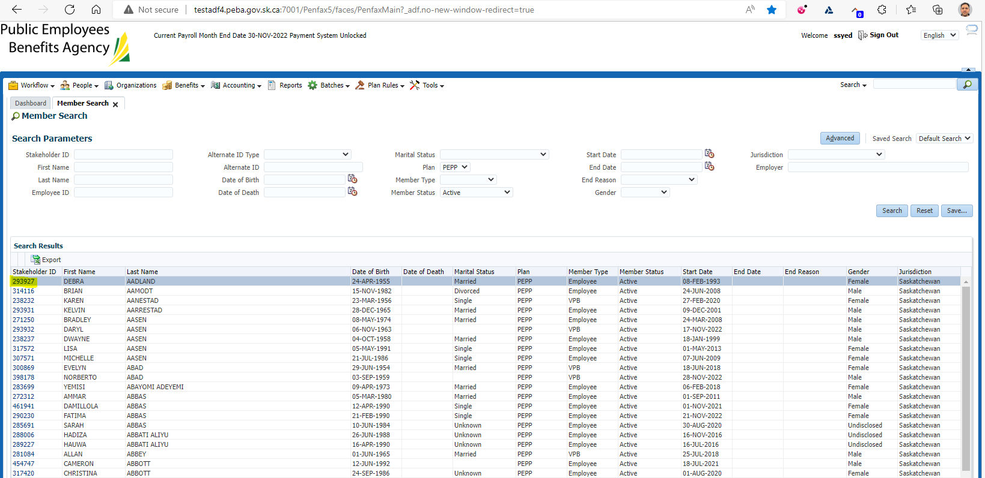

Under Navigation click on Cases  
Click Add Case

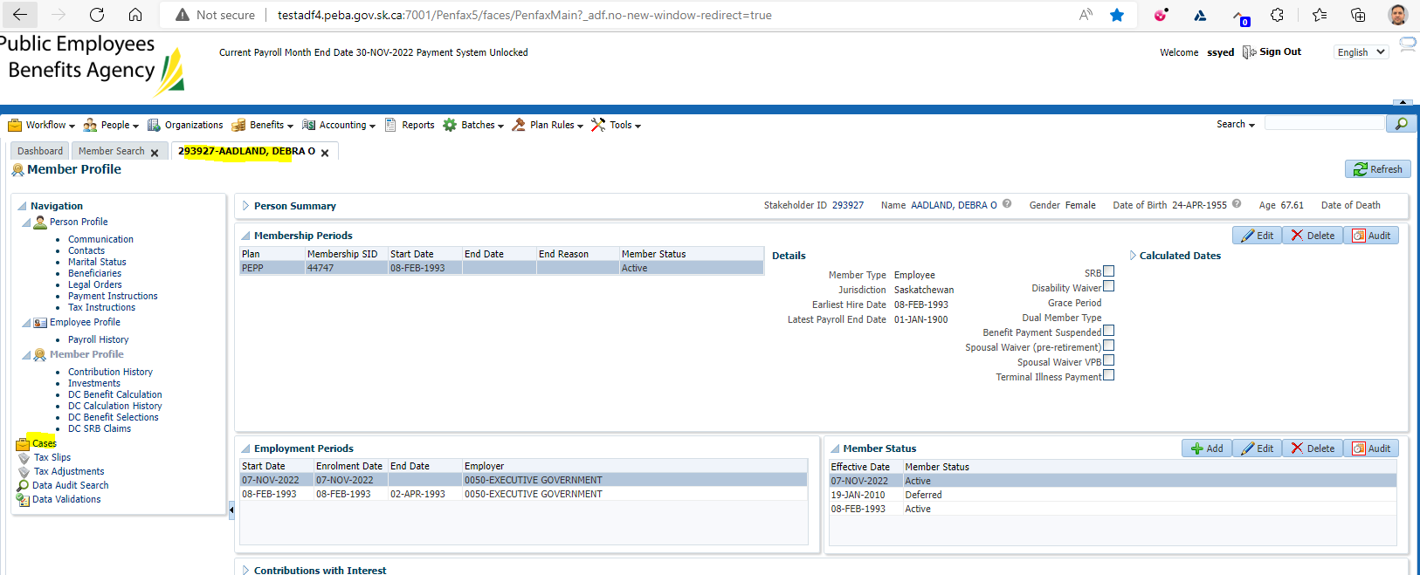

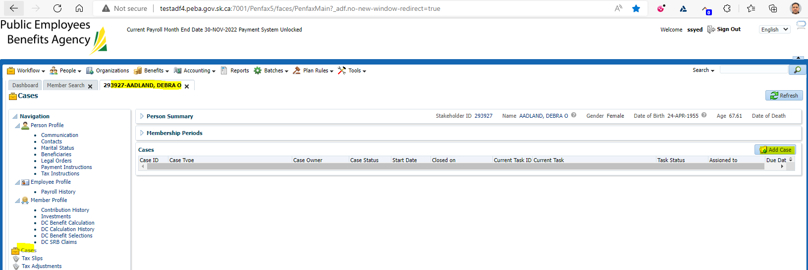

Under Case Type select Member Consultation  
Click Save

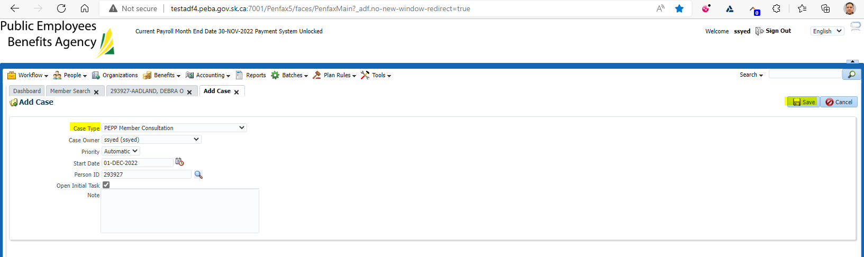

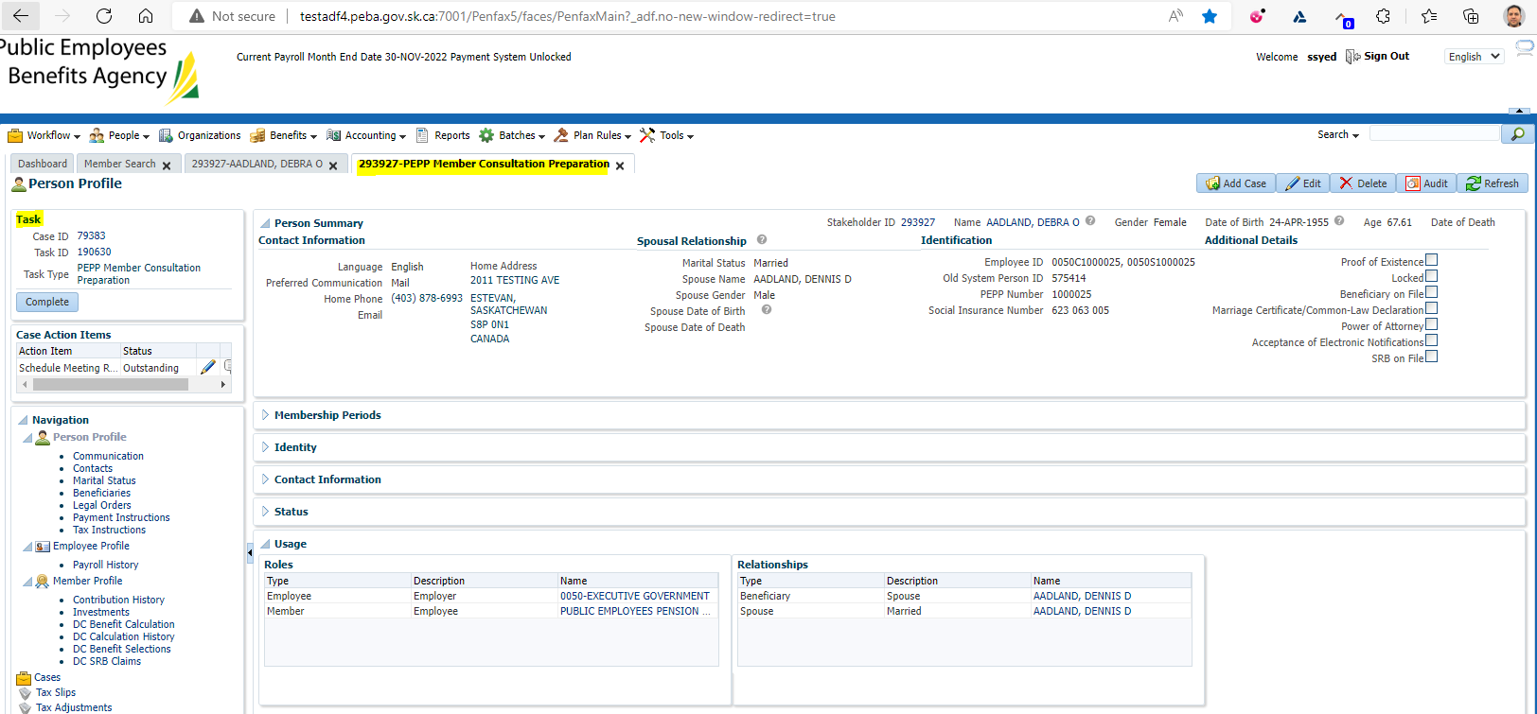

Click on Complete

Complete all necessary steps

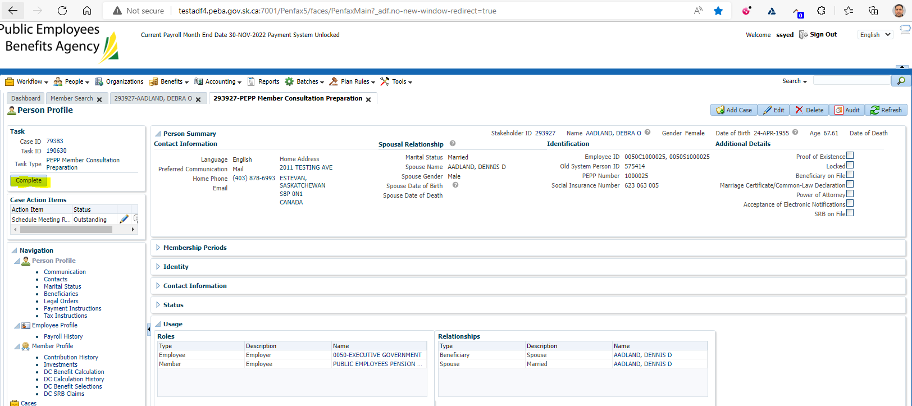

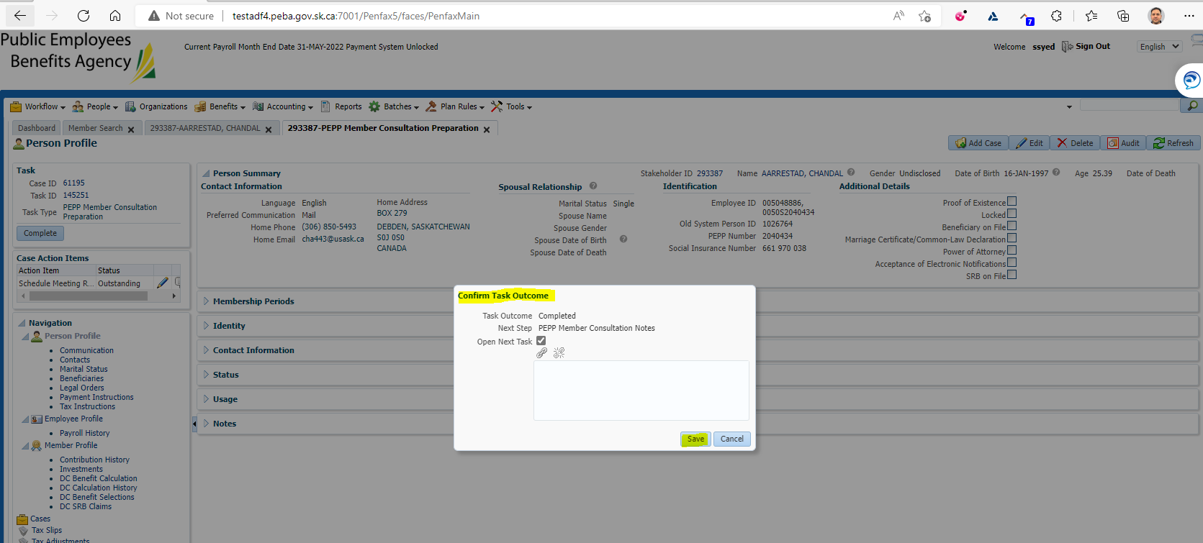

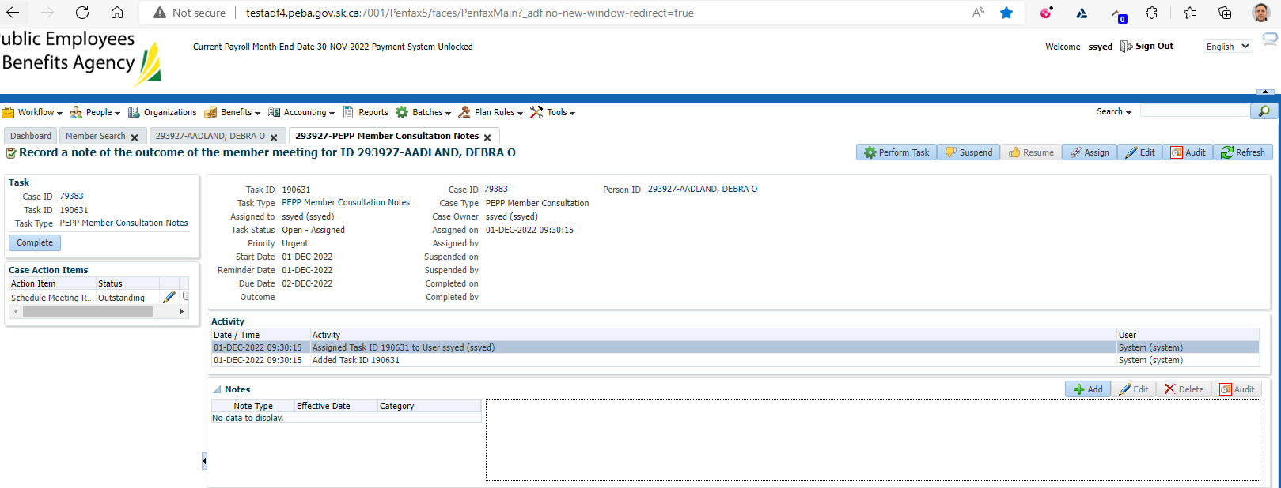

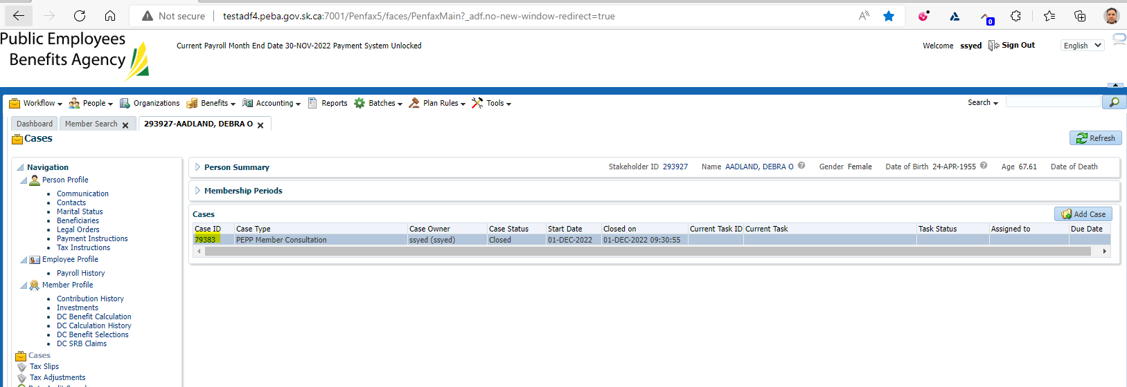

Under Workflow go to Case Search   
Search for the Case you just completed

